ABSTRACT
AirSketch is an innovative gesture-based virtual drawing application designed to transform digital drawing by using real-time hand gesture recognition through a webcam. Unlike traditional drawing systems that rely on devices such as a mouse, stylus, or touchscreen, the application enables users to interact with a virtual canvas using natural hand and finger movements. By extending a single finger, users can draw seamlessly, while predefined gestures allow them to change colors, activate eraser mode, clear the canvas, and control drawing functions efficiently. The system uses computer vision and real-time hand tracking techniques to accurately detect hand landmarks and convert gestures into precise drawing actions with minimal latency. The project integrates technologies such as computer vision, image processing, and human-computer interaction to provide a smooth, touch-free, and user-friendly experience. The salient features of AirSketch include real-time gesture detection, virtual canvas interaction, multiple color selection, eraser functionality, touchless operation, smooth and responsive drawing, and accessibility support for physically challenged users. The application enhances creativity and user engagement while demonstrating the practical implementation of gesture-controlled systems in modern web technologies. Furthermore, AirSketch highlights the growing importance of contactless and intelligent interaction systems in areas such as education, entertainment, design, and smart digital environments, making digital drawing more interactive, efficient, and inclusive.

Keywords: Hand Gesture Recognition, Human–Computer Interaction, MediaPipe, OpenCV, Virtual Drawing, Touchless Interface, Computer Vision, Hand Landmarks, Gesture Evaluation.

CONTENTS
1. INTRODUCTION ........................................................................................................................................................ 4
1.1 Domain Introduction ............................................................................................................................................... 4
1.2 Project Introduction ................................................................................................................................................. 5
1.3 Scope of the Project ................................................................................................................................................. 5
2. LITERATURE SURVEY ............................................................................................................................................. 6
2.1 AO-Finger ................................................................................................................................................................ 6
2.2 OMG-Bench ............................................................................................................................................................. 7
2.3 Air Writing App with Real-Time Hand Tracking and Handwriting Recognition .................................................... 8
2.4 AIR CANVAS HAND TRACKING ....................................................................................................................... 9
2.5A Deep Learning-based Multimodal Depth-Aware Dynamic Hand Gesture Recognition System .......................... 11
2.6 Hand Gesture Recognition using Image Processing and Feature Extraction Techniques ....................................... 12
2.7 Computer Vision-Based Hand Gesture Recognition for Human-Robot Interaction ............................................... 13
2.8 Hand Gesture and Voice-Controlled Mouse for Physically Challenged Using Computer Vision…………………14
2.9 Dynamic Sign Language Recognition in Inclusive Communication Systems…………………………………….15
2.10 Understanding the Faults of JavaScript-Based Deep Learning Systems…………………………………………16
2.11 Painting with Hand Gestures using MediaPipe…………………………………………………………………..17
2.12 Dynamic LIBRAS Gesture Recognition via CNN……………………………………………………………….19
2.13 AirSketch: Generative Motion to Sketch…………………………………………………………………………20
2.14 Virtual Write and Clear Application………...........................................................................................................21
2.15 Virtual Hand Gesture Painting………....................................................................................................................22
3. EXISTING AND PROPOSED SYSTEM ................................................................................................................... 23
3.1 Existing Systems ..................................................................................................................................................... 23
3.2 Limitations of Existing Approaches ....................................................................................................................... 24
3.3 Proposed AirSketch System ................................................................................................................................... 24
3.4 Feature Set .............................................................................................................................................................. 25
3.5 Advantages and Constraints ................................................................................................................................... 25
4. PROBLEM DEFINITION, OBJECTIVES AND REQUIREMENTS ........................................................................ 26
4.1 Problem Definition ................................................................................................................................................. 26
4.2 Objectives ............................................................................................................................................................... 26
4.3 Hardware Requirements ......................................................................................................................................... 27
4.4 Software Requirements .......................................................................................................................................... 27
4.5 Feasibility Analysis ................................................................................................................................................ 27
5. SYSTEM DESIGN ...................................................................................................................................................... 29
5.1 System Architecture ................................................................................................................................................ 29
5.2 Module Description ................................................................................................................................................. 29
5.3 Software Module Interaction ................................................................................................................................... 30
5.4 Data Flow ................................................................................................................................................................. 30
5.5 User Interaction Model ............................................................................................................................................ 31
5.6 User Interface Design .............................................................................................................................................. 32
6. ALGORITHMS AND METHODOLOGY .................................................................................................................. 33
6.1 Video Acquisition .................................................................................................................................................... 33
6.2 Hand Landmark Detection ....................................................................................................................................... 33
6.3 Coordinate Mapping ................................................................................................................................................ 34
6.4 Pinch Detection ........................................................................................................................................................ 34
6.5 Shape Rendering ...................................................................................................................................................... 34
6.6 Canvas Compositing ................................................................................................................................................ 35
6.7 Toolbar Interaction and Debouncing ....................................................................................................................... 35
6.8 Gesture and Tool Mapping ...................................................................................................................................... 35
6.9 Methodology ........................................................................................................................................................... 36
7. SYSTEM IMPLEMENTATION .................................................................................................................................. 37
7.1 Development Environment ..................................................................................................................................... 37
7.2 Main Application Module ....................................................................................................................................... 37
7.3 Hand Tracker Module ............................................................................................................................................. 38
7.4 Virtual Painter Module ............................................................................................................................................ 38
7.5 User Interface Module ............................................................................................................................................. 38
7.6 Evaluation Module .................................................................................................................................................. 38
7.7 Configuration and Dependencies ............................................................................................................................ 39
8. TESTING AND EVALUATION ................................................................................................................................. 40
8.1 Testing Strategy ....................................................................................................................................................... 40
8.2 Pinch Detection Evaluation ..................................................................................................................................... 40
8.3 Evaluation Methodology ......................................................................................................................................... 41
8.4 Evaluation Metrics………………………………………………………………………………………………….41
8.5 Performance Interpretation ...................................................................................................................................... 42
9. RESULTS AND DISCUSSION ................................................................................................................................... 43
9.1 Functional Results ................................................................................................................................................... 43
9.2 Drawing and Shape Results ..................................................................................................................................... 44
9.3 User Interface Results .............................................................................................................................................. 44
9.4 Interaction Characteristics ....................................................................................................................................... 44
9.5 Discussion ................................................................................................................................................................ 45
9.6 Comparison with Related Approaches .................................................................................................................... 45
10. CONCLUSION AND FUTURE SCOPE ................................................................................................................... 46
10.1 Conclusion ............................................................................................................................................................. 46
10.2 Current Limitations ............................................................................................................................................... 46
10.3 Future Enhancements ............................................................................................................................................ 47
10.4 Applications .......................................................................................................................................................... 48
REFERENCES ................................................................................................................................................................. 49

I. INTRODUCTION

1.1 Domain Introduction
Human–computer interaction has progressively moved from keyboard- and mouse-centred interaction toward interfaces that interpret more natural forms of input. Hand gestures are particularly attractive because they allow pointing, selection, manipulation, and continuous movement without a physical controller. Gesture-driven interaction appears in virtual reality, gaming, assistive technology, air-writing, robotics, and creative applications. The literature supplied with this project shows a broad range of approaches, from wearable acoustic-optic sensing to webcam-based landmark tracking and learned temporal gesture models.
Computer vision provides a practical route to touchless interaction because a camera can observe hand movement without requiring the user to wear a sensor. A vision pipeline typically contains image acquisition, hand detection or segmentation, landmark or feature extraction, gesture interpretation, and an application-specific response. The reliability of the final interaction depends not only on the hand-tracking model but also on lighting, camera quality, background conditions, hand occlusion, interaction rules, and the way continuous motion is converted into commands.
AirSketch occupies the application-level end of this design space. It does not attempt to introduce a new hand detector or train a general-purpose gesture classifier. Instead, it uses the established MediaPipe hand-landmark representation and adds deterministic geometric rules for a virtual drawing interface. This makes the interaction logic easy to inspect: the system knows where the fingertip is, measures the distance between two fingertips, and uses that distance to decide whether the user is actively drawing.
.

1.2 Project Introduction
AirSketch receives a live 1280×720 camera stream. The frame is horizontally flipped to provide a mirror-like interaction view and passed to MediaPipe Hands. When a hand is detected, landmark 8, corresponding to the index fingertip, is used as the pointer position. Landmark 12, the middle-finger tip, is used together with landmark 8 to calculate a Euclidean distance. A distance below 70 pixels is interpreted as a pinch and activates the drawing state.
The pointer coordinates are smoothed using the arithmetic mean of the most recent five valid fingertip positions. This reduces small visual jitter without introducing a computationally expensive filter. The system distinguishes the toolbar region from the drawing region. When the smoothed pointer is above the toolbar boundary, it is interpreted as UI input. Otherwise, an active pinch starts or continues drawing. Brush and eraser tools draw continuously between successive points, while geometric tools use a temporary preview and commit the final shape when the pinch is released.

1.3 Scope of the Project
• The project covers real-time single-hand tracking from a conventional RGB webcam.
• The project covers deterministic pinch-based activation and fingertip smoothing.
• The project covers freehand brush, eraser, line, rectangle, circle, filled rectangle, filled circle, and clear-canvas tools.
• The project covers colour selection and ten predefined brush thickness values from 5 to 50 pixels.
• The project covers frame-level evaluation of the pinch detector using labelled samples and standard classification metrics.

II. LITERATURE SURVEY
The literature reviewed for AirSketch spans traditional computer-vision gesture recognition, webcam-based air drawing, MediaPipe-based interfaces, multimodal depth-aware recognition, temporal deep-learning approaches, assistive interaction, and software reliability. The current research paper uses sixteen references, while the earlier project report contains a ten-item survey. The following discussion consolidates the supplied material and relates each group of work to the design decisions made in AirSketch.

2.1 AO-Finger: Hands-free Fine-grained Finger Gesture Recognition via Acoustic-Optic Sensor Fusing, Chenhan Xu, Bing Zhou, Gurunandan Krishnan, and Shree Nayar, 2023
Xu et al. proposed AO-Finger, a hands-free fine-grained finger gesture recognition system designed for wearable and Extended Reality (XR) interaction. The system combines acoustic and optical sensing to recognize natural finger movements without requiring users to hold a controller. It uses two optical sensors to track thumb movement and a modified microphone to capture acoustic signals generated by finger movements. These complementary sensing modalities help distinguish gestures that may produce similar acoustic signals when used alone. The system recognizes three fast gestures—flick, pinch, and tap—and also supports continuous finger swipe tracking. A multimodal CNN-Transformer model is used for fast gesture recognition, while a separate model is used for detecting finger contact during swipe interactions.
The prototype consists of a wrist-worn structure containing optical sensors, a modified MEMS microphone, and a Bluetooth Low Energy controller. The optical sensing system operates at approximately 386 FPS, enabling rapid finger movements to be captured. Experimental evaluation achieved an overall accuracy of 94.83% for fast gesture recognition. The authors also discussed limitations such as partial dependence on external computation, the need for relatively static hand positioning during gesture detection, and the need for larger-scale user evaluation.
The work is relevant to AirSketch because both systems use finger gestures, particularly pinch, for natural human-computer interaction. However, AirSketch uses a conventional camera and MediaPipe hand landmarks instead of specialized acoustic and optical wrist hardware. In AirSketch, fingertip positions and pinch detection are used to control virtual drawing, shapes, and other canvas operations. Therefore, AO-Finger demonstrates the potential of real-time finger gestures for hands-free interaction, while AirSketch applies a camera-based approach to create a gesture-controlled virtual drawing system.
The study also highlights the importance of low-latency and reliable gesture recognition for interactive applications. This is particularly relevant to AirSketch, where continuous hand tracking and quick gesture detection are required to provide a smooth drawing experience. The evaluation methodology of AO-Finger also provides useful guidance for assessing gesture recognition performance using measures such as accuracy, precision, recall, and F1-score.

2.2 OMG-Bench: A New Challenging Benchmark for Skeleton-based Online Micro Hand Gesture Recognition, Haochen Chang, Pengfei Ren, Buyuan Zhang, Da Li, Tianhao Han, Haoyang Zhang, Liang Xie, Hongbo Chen, and Erwei Yin, 2026
Chang et al. introduced OMG-Bench, a large-scale benchmark for online micro hand gesture recognition using hand skeleton data. The work addresses the difficulty of recognizing subtle, rapid, and continuously performed gestures, where different gestures can have very similar movements and gesture boundaries may be difficult to determine. The proposed dataset contains 40 fine-grained gesture classes, 1,272 sequences, and 13,948 gesture instances, including interactions such as tap, double-tap, swipe, pinch, and release. The dataset was created using a synchronized five-camera
RGB-D system, followed by multi-view hand pose estimation and semi-automatic frame-level annotation. The resulting skeletons contain 21 hand joints, with the authors reporting a mean per-joint position error of 2.78 mm on their evaluation set.
To address the challenges of online recognition, the authors proposed Hierarchical Memory-Augmented Transformer (HMATr), an end-to-end framework that performs gesture detection and classification together. The method uses an ST-GCN backbone to extract skeleton features, followed by frame-level and window-level memory banks that preserve information from previous time windows. Position-aware learnable queries are then used to capture the location and semantic information of gestures. This approach is particularly useful for continuous gesture streams because it reduces the loss of temporal information that can occur when independent sliding windows are processed. On OMG-Bench, HMATr achieved a 89.2% detection rate, with a 0.22 false-positive score, and also showed lower inference delay than the compared methods. The authors' ablation study further showed that removing the memory components or position-aware queries reduced performance, demonstrating their contribution to online recognition.
The study is relevant to AirSketch because both systems rely on hand-skeleton/landmark information and real-time gesture interaction. AirSketch currently uses MediaPipe hand landmarks and geometric distance between the index and middle fingertips to detect a pinch gesture, whereas OMG-Bench focuses on recognizing a much wider range of subtle gestures from continuous skeleton sequences.

2.3 Air Writing App with Real-Time Hand Tracking and Handwriting Recognition using Fingertip Detection and Drawing, Heena and Dr. Sandeep Ranjan, 2023
Heena and Dr. Sandeep Ranjan proposed an air-writing application that enables users to write, draw, and erase in a virtual canvas using real-time hand tracking and fingertip detection. The system uses OpenCV and MediaPipe to process webcam video and identify 21 hand landmarks, including the fingertip. The detected fingertip coordinates are continuously tracked to interpret hand movements and convert them into drawing actions. The authors use Euclidean distance-based gesture recognition to distinguish actions such as drawing and erasing. The application also provides features such as color selection, adjustable line thickness, brush size, and switching between drawing and erasing modes.
The study additionally focuses on handwriting recognition after the user's writing has been captured on the virtual canvas. Several preprocessing techniques, including auto-orientation, auto-contrast adjustment, adaptive histogram equalization, and grayscale conversion, are applied to improve recognition under different conditions. The paper evaluates the handwriting recognition system using accuracy, precision, recall, and F1-score. It reports an overall accuracy of 86.36%, with a precision of 90.91%, recall of 83.33%, and F1-score of 86.96% for the reported drawing class. The authors also discuss challenges such as variations in lighting, handwriting styles, hand speed, and user posture, which can affect real-world performance.
This work is highly relevant to AirSketch because both systems use webcam-based hand tracking, fingertip movement, and a virtual canvas to provide non-contact drawing interaction. However, AirSketch extends this concept by using gesture-based controls for functions such as brush, eraser, colors, and geometric shapes, rather than focusing mainly on handwriting recognition. The paper therefore provides a strong foundation for AirSketch's use of MediaPipe hand landmarks and fingertip tracking, while also highlighting the importance of handling environmental and user-related variations for reliable real-time interaction.

2.4 AIR CANVAS HAND TRACKING, Swathi. A, 2024
Swathi. A proposed an Air Canvas Hand Tracking system that allows users to draw and interact with a virtual canvas using real-time hand gestures. The system uses a standard webcam along with OpenCV and MediaPipe to capture and process hand movements. MediaPipe detects hand landmarks and provides 21 joint coordinates, which are used to identify finger positions and interpret gestures. The proposed system supports drawing, color selection, brush-size adjustment, and other canvas operations without requiring physical contact with an input device. The paper emphasizes real-time processing, intuitive interaction, portability, and low cost because it relies on commonly available hardware and open-source libraries.
The system processes webcam frames by converting the captured images from BGR to RGB and identifying the position of the fingers through MediaPipe. The index fingertip is primarily used for drawing, while different finger gestures can be used for selecting shapes, colors, and tools. The system also includes functionality for saving the completed canvas as an image. Its design focuses on providing immediate visual feedback as the user's gestures are converted into digital drawing commands. The paper identifies environmental factors such as lighting, clutter, and hand occlusion as challenges that can affect gesture recognition.
This work is highly relevant to AirSketch because both systems use camera-based hand tracking, MediaPipe landmarks, fingertip movement, and a virtual canvas for non-contact drawing. The proposed Air Canvas system is particularly similar to AirSketch in its use of real-time finger tracking and gesture-based controls for drawing, colors, and brush settings. However, AirSketch extends this concept by incorporating pinch-based interaction, multiple drawing tools, geometric shapes, and gesture evaluation.
The paper therefore supports the use of MediaPipe and real-time hand landmarks as an effective foundation for gesture-controlled drawing systems, while also highlighting environmental factors that should be considered when improving AirSketch's reliability.

2.5 A Deep Learning-based Multimodal Depth-Aware Dynamic Hand Gesture Recognition System, Hasan Mahmud, Mashrur M. Morshed, and Md. Kamrul Hasan, 2021
Mahmud et al. proposed a deep learning-based multimodal system for dynamic hand gesture recognition using depth information and 2D hand-skeleton coordinates. The authors identified that raw depth images often have low contrast in hand regions, making fine details such as finger orientation, finger overlap, and palm structure difficult to distinguish. To address this, they introduced Grayscale Variation (gVar), a preprocessing technique that quantizes continuous depth values into discrete gray levels, producing sharper contrast between important regions of the hand. The processed depth information is then combined with 2D skeleton coordinates to provide complementary spatial and temporal information for gesture recognition.
The proposed architecture is a feature-level multimodal fusion CRNN consisting of two main branches. The first branch uses a CNN followed by a bidirectional LSTM to extract spatial and temporal features from depth-image sequences, while the second uses an LSTM to process 2D skeleton joint sequences. Their extracted features are concatenated and passed to a classification network. The authors also reduce the depth-image resolution to 50×50 and introduce Batch Normalization, dropout, and other regularization techniques to reduce overfitting and model complexity. The proposed model contains approximately 4.4 million trainable parameters, compared with more than 31 million in the previous fusion approaches.
The system was evaluated on the DHG-14/28 and SHREC-2017 datasets. On DHG-14/28, the proposed method achieved 90.21% accuracy for 14 gestures and 88.64% for 28 gestures, while achieving 93.33% and 90.24% respectively on SHREC-2017. The study also showed that gVar improved recognition, particularly for fine-grained gestures, although some confusion remained between visually similar gestures such as grab and pinch. This work is relevant to AirSketch because both systems use hand-related visual information and gesture characteristics for human-computer interaction. However, AirSketch uses MediaPipe hand landmarks from a conventional camera and relies mainly on fingertip geometry rather than depth maps and deep multimodal sequence models. The paper nevertheless provides useful insights into improving gesture recognition through temporal information, multimodal features, preprocessing, and robust evaluation, which could be considered for future improvements to AirSketch.

2.6 Hand Gesture Recognition using Image Processing and Feature Extraction Techniques, Ashish Sharma, Anmol Mittal, Savitoj Singh, and Vasudev Awatramani, 2020
Sharma et al. proposed a hand gesture recognition system for identifying and classifying American Sign Language (ASL) gestures from images captured under different environmental conditions. The study focuses on improving recognition by applying image preprocessing and feature extraction techniques before classification. The authors compare Histogram of Oriented Gradients (HOG), Principal Component Analysis (PCA), and Local Binary Patterns (LBP) with their proposed approach based on Canny edge detection, ORB feature extraction, and Bag of Features. The dataset contains 87,000 images representing 29 classes, including the 26 alphabets, “nothing,” space, and delete gestures.
In the proposed method, the input RGB image is first converted into grayscale and Canny edge detection is applied to reduce background noise and retain important hand edges. ORB is then used to detect and extract visual features from the hand. The extracted descriptors are grouped using K-means clustering to generate a Bag-of-Words representation containing 150 visual codewords. These features are subsequently classified using Random Forest, Naïve Bayes, SVM, Logistic Regression, KNN, and Multilayer Perceptron. The results show that the proposed ORB-based approach achieves 95.81% accuracy with KNN and 96.96% with MLP, demonstrating that compact feature representations can provide effective gesture classification.
This study is relevant to AirSketch because both systems use computer vision techniques to interpret hand information for human-computer interaction. The paper demonstrates the importance of preprocessing, feature extraction, and classification in improving recognition performance, while AirSketch uses MediaPipe hand landmarks and fingertip coordinates for real-time interaction rather than traditional image descriptors. The authors also identify an important limitation: their system was tested only on static gesture images, with future work proposed for dynamic real-time gesture recognition. This distinction is relevant to AirSketch, which operates continuously on webcam frames and uses hand movement and pinch-based interaction

2.7 Computer Vision-Based Hand Gesture Recognition for Human-Robot Interaction: A Review, Jing Qi, Li Ma, Zhenchao Cui, and Yushu Yu, 20242.8 Research Gap
Qi et al. presented a comprehensive review of computer vision-based hand gesture recognition for human-robot interaction (HRI). The paper examines how hand gestures can provide natural and intuitive communication between humans and intelligent systems, particularly robots. The authors classify gesture recognition approaches into sensor-based and vision-based methods, discussing data gloves, EMG, Wi-Fi/radar, monocular cameras, and RGB-D cameras. For vision-based recognition, the review organizes the complete recognition process into four major stages: data acquisition, gesture detection and segmentation, feature extraction, and gesture classification.
The review discusses numerous techniques used at each stage, including image grayscaling, smoothing, edge detection, morphological processing, thresholding, skin-color segmentation, contour-based segmentation, and motion tracking. For feature extraction, both global and local features such as HOG, LBP, SIFT, SURF, PCA, and LDA are examined. The paper also compares traditional classification techniques such as template matching, DTW, HMM, SVM, and KNN with deep learning approaches. The authors note that deep learning can automatically extract gesture features and provide greater robustness, although it requires larger datasets and higher computational resources.
The paper identifies several challenges that remain important for real-world gesture recognition, including complex backgrounds, lighting variations, hand occlusion, camera distance, hand anatomy, training-data limitations, and real-time processing requirements. It highlights the need for more diverse datasets and improved recognition speed and reliability. The review concludes that RGB-D and vision-based approaches have strong potential for dynamic and static gesture recognition in robotic applications, while future systems are expected to become more accurate, real-time, reliable, and personalized. This work is relevant to AirSketch because it provides a broader foundation for understanding the computer-vision pipeline behind AirSketch's camera-based hand tracking and highlights areas such as segmentation, feature extraction, real-time performance, and robustness that are important for gesture-controlled interfaces.

2.8 Hand Gesture and Voice-Controlled Mouse for Physically Challenged Using Computer Vision, Aarti Morajkar, Atheena Mariyam James, Minoli Bagwe, Aleena Sara James, and Aruna Pavate, 2023
Morajkar et al. proposed a hand gesture and voice-controlled virtual mouse designed to provide a hands-free alternative to conventional mouse interaction. The system uses computer vision and deep learning to recognize hand gestures and map them to different computer operations. The authors use an EfficientNetB4-based CNN trained on a custom dataset for gesture recognition, while MediaPipe can be incorporated for hand tracking. The main objective is to provide a cost-effective and intuitive HCI system without requiring additional specialized hardware such as sensors or controllers.
The proposed system supports several mouse and computer operations, including cursor movement, left click, right click, double click, scrolling, drag and drop, multiple-item selection, volume control, and brightness control. A voice assistant is also integrated to provide additional hands-free commands such as file navigation, Google search, copy and paste, and system control. The authors tested the system under different conditions, including varying camera distances, lighting conditions, backgrounds, and the use of left, right, and both hands. The results showed high gesture-classification performance, although the authors observed a delay of a few seconds for mouse actions.
This study is highly relevant to AirSketch because both systems use a camera-based, touchless interface to convert hand gestures into computer actions. However, the purpose and implementation differ: the proposed virtual mouse focuses on replacing conventional mouse operations using a trained deep-learning gesture classifier, whereas AirSketch uses MediaPipe hand landmarks and fingertip-distance-based pinch detection to enable virtual drawing and tool selection. The paper also highlights practical challenges such as lighting and skin-color variations, which are important considerations for camera-based gesture systems. Its future work includes expanding interaction functions and exploring eye-based control for users unable to use their hands

2.9 MediaPipe-LSTM-Enhanced Framework for Real-Time Dynamic Sign Language Recognition in Inclusive Communication Systems, N. Anithadevi, SatheeshKumar Palanisamy, S. Saranya Rubini, and Sachin Shrestha, 2025
Anithadevi et al. proposed a MediaPipe-LSTM-based framework for real-time dynamic sign language recognition, focusing on continuous gesture sequences rather than isolated static hand gestures. The system combines MediaPipe Holistic for extracting hand, facial, and body landmarks with an enhanced stacked Long Short-Term Memory (LSTM) network for learning temporal relationships between consecutive gestures. A dedicated dataset containing dynamic Indian Sign Language gestures was developed, while preprocessing includes frame extraction, resizing, normalization, data augmentation, and landmark extraction. The system further incorporates a transformer-based paraphrasing module that converts recognized gesture sequences into semantically meaningful text and search queries.
The proposed model uses three LSTM layers followed by dense layers for sequential gesture classification. MediaPipe provides structured landmark features, allowing the model to focus on meaningful hand, face, and posture information instead of processing raw video alone. The authors report 97% accuracy, 98.17% precision, and 94.88% F1-score, with the comparative evaluation indicating approximately 25 ms per frame processing time. Their ablation study further demonstrated the contribution of each component: removing MediaPipe reduced accuracy by 7.8%, removing attention reduced it by 4.5%, and replacing LSTM with a CNN resulted in an 11.4% decrease, highlighting the importance of temporal sequence modeling.
This work is highly relevant to AirSketch because both systems use webcam input, MediaPipe landmarks, and real-time hand movement analysis. However, their objectives differ: the proposed system performs continuous sign-language recognition and converts gesture sequences into meaningful language, whereas AirSketch uses hand landmarks primarily for drawing interaction and gesture-based tool control. The paper provides useful direction for future AirSketch improvements because it demonstrates how temporal models such as LSTM can capture movement patterns across multiple frames instead of relying only on individual-frame fingertip distances. It also emphasizes the importance of robust preprocessing, balanced datasets, and evaluation using precision, recall, and F1-score.

2.10 Towards Understanding the Faults of JavaScript-Based Deep Learning Systems, Lili Quan, Qianyu Guo, Xiaofei Xie, Sen Chen, Xiaohong Li, and Yang Liu, 2022
Quan et al. presented an empirical study on the faults and quality issues of JavaScript-based deep learning systems, with a particular focus on TensorFlow.js. The authors analyzed 700 real-world faults collected from 72 GitHub repositories, including TensorFlow.js, third-party deep learning libraries, and web-based deep learning applications. The study categorizes these faults according to their symptoms, root causes, and fixing methods. The authors identified 26 fault symptoms, 17 root causes, and 16 fix patterns, while also studying faults across different stages of the deep learning development lifecycle.
The study found that crashes were the most common fault, accounting for 318 of the 700 identified faults, followed by build and initialization failures and poor-performance problems. Important root causes included incorrect code logic, dependency errors, API misuse, data or model inaccessibility, device incompatibility, browser incompatibility, and limitations of JavaScript-specific backends such as WebGL and Wasm. The authors also examined common solutions, including changing software versions, modifying dependencies, changing execution environments or backends, correcting model paths, and modifying API usage. These findings demonstrate that JavaScript-based deep learning systems can face problems not only in their models but also in their supporting software and execution environments.
This work is relevant to AirSketch mainly from a software reliability and implementation perspective. AirSketch depends on computer-vision libraries and continuous real-time processing, meaning that issues such as incorrect API usage, dependency problems, processing delays, and runtime errors can affect its performance. Unlike the gesture-recognition papers discussed earlier, this study does not propose a new gesture-recognition method. Instead, it provides useful guidance for testing, debugging, performance evaluation, and reliable implementation of AI-based interactive systems. Its findings can therefore support future improvements to AirSketch by encouraging evaluation of the complete system rather than focusing only on gesture-recognition accuracy.

2.11 Painting with Hand Gestures using MediaPipe, R. Vasavi, Nenavath Rahul, A. Snigdha, K. Jeffery Moses, and S. Vishal Simha, 2022
Vasavi et al. proposed a real-time painting application controlled through hand gestures, allowing users to draw on a virtual canvas without using a mouse, keyboard, or other physical input device. The system uses a webcam to capture hand movements and combines OpenCV and MediaPipe for hand detection and tracking. MediaPipe's palm detection and hand landmark models are used to identify the hand and locate the index fingertip, which acts as the primary input for drawing. The authors describe the system as a contactless human-computer interaction approach and highlight its potential applications in areas such as virtual environments, sign-language interaction, industrial automation, and rehabilitation.
The application continuously processes webcam frames and determines the user's hand and finger positions using MediaPipe. When the index finger is raised, the user can draw on the canvas according to the movement of the fingertip. Other hand configurations are used for additional operations, such as moving around the screen, selecting a colour, and clearing the canvas. The paper emphasizes MediaPipe's low-latency processing, modular structure, and ability to provide 21 hand landmark coordinates, while OpenCV is responsible for image and video processing. The results demonstrate that the system can detect the live hand, track the index fingertip, and display freehand drawings and writing on the virtual canvas in real time.
This work is highly relevant to AirSketch because both systems use webcam-based hand tracking, MediaPipe landmarks, fingertip movement, and a virtual drawing canvas for contactless interaction. However, AirSketch extends this basic approach by using pinch-based interaction and providing multiple drawing tools such as brush, eraser, lines, circles, and rectangles. The paper therefore provides direct support for AirSketch's choice of MediaPipe and OpenCV as the core computer-vision technologies. It also demonstrates that fingertip tracking can provide responsive real-time drawing, while the paper notes that variations in hand position, orientation, hand size, and lighting remain challenges for vision-based gesture systems.

2.12 Dynamic LIBRAS Gesture Recognition via CNN over Spatiotemporal Matrix Representation, Jasmine Moreira, 2026
Moreira proposed a dynamic hand gesture recognition system that combines the MediaPipe Hand Landmarker with a convolutional neural network (CNN) to recognize LIBRAS gestures for home automation control. MediaPipe extracts 21 hand keypoints from each video frame, which are then organized into a 90×21 spatiotemporal matrix representing the x, y, and z coordinates across 30 frames. This matrix is converted into a grayscale image and classified using a lightweight CNN. The system covers 11 static and dynamic gesture classes and uses a sliding-window approach for continuous real-time recognition without requiring recurrent neural networks.
The proposed CNN contains three convolutional layers and two dense layers, with the selected configuration containing approximately 25,000 parameters. During real-time inference, each captured frame is triplicated in a buffer so that overlapping windows can represent continuous movements. Predictions are accepted only when the confidence exceeds 98%. The system achieved 95% accuracy under low-light conditions and 92% under normal lighting. However, the experiments were performed using a single user, and the authors note that the results may not generalize to users with different hand anatomy, gesture speed, or expression style.
This work is relevant to AirSketch because both systems use MediaPipe hand landmarks for real-time gesture-based interaction. The main difference is that AirSketch currently uses fingertip geometry and pinch detection to control drawing, whereas this paper processes sequences of landmarks with a CNN to recognize complete static and dynamic gestures. Its use of temporal information and overlapping windows could be useful for future AirSketch improvements involving more complex gestures or commands. The paper also highlights the importance of testing across different users and lighting conditions, which are relevant considerations for improving the robustness of AirSketch.

2.13 AirSketch: Generative Motion to Sketch, Hui Xian Grace Lim, Xuanming Cui, Yogesh S. Rawat, and Ser-Nam Lim, 2024
Lim et al. introduced AirSketch, a marker-less air-drawing approach that generates clean and visually coherent sketches directly from hand movements captured using a standard camera. The authors address limitations of conventional AR/VR drawing systems, which may require headsets, controllers, or digital markers. Their approach first uses a hand-tracking algorithm to obtain a noisy representation of the user's hand motion and then applies a controllable image diffusion model to transform this noisy input into a clean sketch. The authors created both synthetic and real air-drawing datasets to evaluate the proposed approach.
The proposed method uses ControlNet with Stable Diffusion XL (SDXL) and an augmentation-based self-supervised training procedure. During training, clean sketches are deliberately modified using different types of noise, including hand jitters, stroke distortions, incorrect positioning, and false strokes, allowing the model to learn how to recover the intended sketch. The real air-drawing dataset contains videos recorded at 1280×720 resolution and 30 FPS. With augmentation-based training, the model improved the similarity between generated and ground-truth sketches; for the real dataset, SDXL achieved an SSIM of 0.64, compared with 0.55 for the original tracking input, while Chamfer Distance decreased from 32.36 to 25.46.
This work is relevant to AirSketch because it demonstrates how noisy hand-tracking data can be converted into cleaner and more aesthetically consistent drawings. Both systems rely on camera-based hand tracking, with the paper specifically noting that MediaPipe can provide 21 hand landmarks from RGB images or video. However, the proposed system differs significantly from the AirSketch project because it focuses on generative sketch refinement using diffusion models, whereas AirSketch provides direct real-time drawing and interaction through gestures and drawing tools. The paper's discussion of tracking errors, hand jitter, unintended strokes, and false strokes is particularly relevant to improving the robustness and visual quality of AirSketch in future work.

2.14 Virtual Write and Clear Application: A Gesture-based Drawing Tool using Mediapipe and OpenCV, Samruddhi Barade, Payal Kadam, Pradnesh Vedpathak, and N.S. Bahirame, 2025
Barade et al. presented a gesture-based virtual drawing application that allows users to draw without traditional input devices such as a mouse, stylus, or touchscreen. The system uses Python, OpenCV, and MediaPipe to track hand movements through a webcam and map them to actions on a virtual canvas. MediaPipe provides 21 hand landmarks for identifying gestures, while the user's index-fingertip movement is used to draw lines in real time. The application also includes gestures for clearing the canvas and changing colours, providing a contactless human-computer interaction system.
The system follows a modular architecture consisting of video capture, hand tracking, gesture recognition, drawing interface, and user interaction modules. Specific gestures are mapped to functions such as colour selection and erasing; for example, raising the thumb and index finger together can trigger a colour change. The authors report that the application maintained an average latency of 50 ms, while hand-tracking accuracy was reported to be above 95%. The results demonstrate real-time hand tracking, drawing, colour selection, and canvas clearing through gestures.
This work is highly relevant to AirSketch because both systems use MediaPipe, OpenCV, webcam-based hand tracking, and gesture-controlled virtual drawing. However, AirSketch extends this concept with pinch-based interaction and a wider range of drawing tools, including geometric shapes, brush and eraser controls. The paper's modular architecture is also closely related to AirSketch's separation of hand tracking, gesture detection, and drawing functionality. Its reported latency and accuracy provide useful reference points when evaluating the responsiveness and reliability of AirSketch. The authors also identify future improvements such as advanced gesture recognition and multi-hand support, which could be considered for further development

2.15 Virtual Hand Gesture Painting, Satyam V. Tiwari, Deep A. Vartak, Vivek R. Verma, Anasali I. Sayyed, and Ms. Soniya Khatu, 2022
Tiwari et al. proposed a virtual hand gesture painting system that enables users to draw and write on a digital canvas without relying on physical input devices. The system uses a webcam along with OpenCV and MediaPipe to detect and track hand movements in real time and translate them into drawing actions. MediaPipe is used for hand tracking and landmark detection, while the user's finger movements are mapped to the virtual canvas. The system supports drawing, colour selection, erasing, and shape creation, providing a contactless approach to digital painting.
The proposed system detects the user's hand through the camera and provides different interaction modes based on the detected fingers. When only the index finger is raised, the user enters drawing mode, while the index and middle fingers together are used to select options such as the brush, shapes, and eraser. The system also allows users to select different colours from the interface. The implementation section demonstrates real-time hand landmark detection and drawing by moving the index finger in front of the camera. The authors further describe connecting the system to a mobile device so that the drawing output can also be displayed on the phone.
This work is highly relevant to AirSketch because it uses a very similar combination of OpenCV, MediaPipe, fingertip tracking, gesture-based tool selection, and virtual drawing. It is particularly close to AirSketch in its use of separate gestures for drawing, selecting tools, shapes, and erasing. However, AirSketch uses pinch-based interaction and includes additional drawing and evaluation features. The paper also identifies challenges such as variations in hand size, position, orientation, and lighting conditions, which are important considerations for improving AirSketch's robustness.

III. EXISTING AND PROPOSED SYSTEM

3.1 Existing Systems

3.1.1 Microsoft Kinect
Microsoft Kinect represents a class of gesture-interaction systems that combine RGB imaging with depth and infrared sensing. Such systems can observe larger body movements and provide richer spatial information than a conventional RGB webcam. They have been used for gaming, interactive installations, rehabilitation research, and other motion-controlled applications.
For the AirSketch use case, the important limitation is the dependency on dedicated sensing hardware. The need for a specialised sensor increases cost and reduces portability compared with a system that uses a webcam already available on a laptop or desktop computer.

3.1.2 Leap Motion Controller
The Leap Motion Controller uses optical sensing to track hands and fingers at high spatial detail. It is designed specifically for hand interaction and has been used in virtual reality, 3D modelling, simulation, and interactive systems. Its dedicated sensing capability can provide precise finger information, but it introduces an additional hardware dependency and requires suitable placement and calibration.

3.1.3 Conventional Digital Drawing
Mouse- and stylus-based drawing systems provide mature and precise interaction. However, they require physical contact and are not designed for touchless use. Touchscreens remove the mouse requirement but still depend on physical contact with a display surface. AirSketch explores a different interaction model in which the user’s fingertip acts as the pointer and pinch acts as the activation mechanism.

3.2 Limitations of Existing Approaches
• Specialized sensors can increase cost and reduce portability.
• Depth and multimodal systems may require additional computation and calibration.
• Marker- or colour-based approaches can require an extra physical object or controlled visual conditions.
• Learned dynamic gesture systems require datasets, training, validation, and model maintenance.
• Simple drawing systems may not separate pointer movement from intentional drawing clearly.
• Real-time camera systems remain sensitive to lighting, background clutter, motion blur, and hand occlusion.

3.3 Proposed AirSketch System
The proposed AirSketch system uses a conventional RGB webcam and a Python-based real-time processing loop. The webcam supplies frames at the requested 1280×720 working resolution. OpenCV horizontally flips each frame before the frame is passed to the virtual painter. MediaPipe Hands estimates 21 hand landmarks. The index and middle fingertip coordinates are extracted, and their Euclidean distance determines the pinch state.
The current implementation supports eight tools: brush, eraser, rectangle, circle, line, filled rectangle, filled circle, and clear canvas. Twelve colours are available through the toolbar. Brush thickness is selected from ten values: 5, 10, 15, 20, 25, 30, 35, 40, 45, and 50 pixels. A temporary canvas is used for shape previews so that the persistent canvas is not modified until the user releases the pinch.
Gesture-based interaction eliminates the need for physical input devices during drawing operations.
The system maintains the selected tool, colour, and brush thickness throughout the drawing session.

3.4 Feature Set
Feature | Implementation Behaviour
Hand tracking | MediaPipe Hands; one detected hand; 21 landmarks
Virtual pointer | Index fingertip landmark 8
Activation | Pinch when distance between landmarks 8 and 12 is below 70 pixels
Smoothing | Five-sample arithmetic moving average
Freehand brush | Connect successive smoothed fingertip points
Eraser | Draw black trajectory using current brush thickness
Shapes | Line, rectangle, circle, filled rectangle, filled circle
Colour selection | Fingertip selection from twelve toolbar colour circles
Brush size | Ten levels from 5 to 50 pixels
Canvas clear | Reinitialize persistent 720×1280 canvas
Toolbar debounce | 0.3 seconds between UI selections
Evaluation | Frame-level labelled pinch evaluation, CSV and text report

3.5 Advantages and Constraints
AirSketch has the practical advantage of using a standard camera and a small set of dependencies. The deterministic interaction model is transparent and easy to debug. The application can also be modified without retraining a gesture classifier. Its constraints are equally important: only one hand is processed, the coordinate mapping is tied to 1280×720, the pinch threshold is fixed at 70 pixels, and the system has a limited gesture vocabulary. The research paper identifies these limitations and proposes normalized thresholds, multi-hand support, and optional learned classification as future directions.

IV. PROBLEM DEFINITION, OBJECTIVES AND REQUIREMENTS

4.1 Problem Definition
Conventional digital drawing interfaces depend on physical input devices. Although these devices are effective, they require contact and can be inconvenient in situations where touchless interaction is preferred. Existing gesture systems can also introduce dedicated hardware, complex models, or limited application functionality. The problem addressed by AirSketch is therefore to design and implement a real-time virtual drawing interface that can translate natural hand movement from a standard RGB webcam into controlled drawing actions while maintaining a clear distinction between pointer movement and intentional activation.

4.2 Objectives
1. To develop a real-time gesture-controlled virtual drawing application using a standard RGB webcam.
2. To detect and track hand landmarks using MediaPipe.
3. To use a deterministic and interpretable gesture rule for drawing activation.
4. To reduce fingertip jitter through lightweight smoothing.
5. To provide freehand drawing and geometric drawing primitives.
6. To provide colour selection, brush-size adjustment, erasing, and canvas clearing.
7. To evaluate pinch detection using labelled samples and standard classification metrics.
8. To document limitations and identify technically plausible future enhancements.

4.3 Hardware Requirements
The current implementation requires a computer capable of running Python, a working webcam, and sufficient CPU resources for real-time MediaPipe processing. No depth camera, wearable sensor, or graphics-processing unit is specified by the repository. The actual experience can still vary with camera quality, lighting, processor performance, and available memory.

4.4 Software Requirements
Software / Package | Version in Repository | Purpose
Python | Project runtime | Application execution
MediaPipe | 0.10.21 | Hand landmark detection and tracking
OpenCV | 4.10.0.84 | Camera input, rendering, image operations, display
NumPy | 1.26.4 | Canvas arrays and numerical operations
CSV / datetime | Python standard library | Evaluation logging and timestamps

4.5 Feasibility Analysis

4.7.1 Technical Feasibility
The project is technically feasible because its main components are available as established Python packages and the interaction logic is deterministic. The system uses a conventional RGB webcam for image acquisition and does not depend on specialized sensing equipment. OpenCV provides the required image-processing and camera-handling functionality, while MediaPipe Hands provides real-time hand landmark detection. The current repository separates camera acquisition, hand tracking, drawing, user interface, and evaluation into individual modules, making the system easier to maintain, test, and modify.

4.7.2 Economic Feasibility
The system is economically feasible because it does not require dedicated depth cameras, motion sensors, graphics tablets, or other specialized hardware. A conventional RGB webcam is sufficient for capturing the user's hand movements, making the system suitable for implementation on commonly available computers and laptops. This reduces the initial hardware investment compared with gesture-based systems that depend on specialized sensing devices.

4.7.3 Operational Feasibility
The system is operationally feasible because its interaction model is simple and can be performed using natural hand movements. The user moves the fingertip to position the virtual cursor and uses a pinch gesture between the index and middle fingers to activate drawing or tool operations. The toolbar provides direct access to drawing tools, colours, brush thickness, and canvas controls, reducing the need to remember multiple complex gestures.

4.7.4 Schedule Feasibility
The project is schedule-feasible because its modular structure allows development to be divided into clearly defined stages. The initial stage involves setting up webcam acquisition and real-time hand tracking, followed by implementation of pinch detection and fingertip-based interaction. Subsequent stages include the development of drawing tools, colour and brush controls, toolbar integration, shape-preview functionality, and canvas management.

\

V. SYSTEM DESIGN

5.1 System Architecture
The processing pipeline begins with the default webcam. The main module requests a 1280×720 capture size and horizontally flips each frame. The hand tracker converts the BGR frame to RGB before calling MediaPipe Hands. If no hand is detected, the tracker returns None and the persistent canvas remains unchanged. If a hand is detected, landmarks 8 and 12 are converted from normalized coordinates to pixel coordinates.
The landmark processor calculates the Euclidean distance between the two fingertip points. A value below 70 pixels sets the pinch state to true. The index fingertip is passed through a five-sample moving average before it is used as the interaction point. The virtual painter then decides whether the pointer is in the toolbar or the drawing region. In the toolbar, the UI module handles selection. In the drawing region, the pinch state controls drawing and shape operations.

5.2 Module Description
Module | Primary Responsibility | Important Data / State
main.py | Camera, application loop, keyboard evaluation controls | capture object, painter, evaluation mode
hand_tracker.py | MediaPipe initialization, landmarks, pinch, smoothing | 21 landmarks, fingertip history, pinch state
virtual_painter.py | Canvas, drawing state, tools, compositing | canvas, temp_canvas, tool, colour, thickness
ui.py | Toolbar drawing and pointer-based controls | colour positions, tool bounds, size controls
evaluation.py | Ground-truth collection and metrics | TP, TN, FP, FN, samples, CSV log

5.3 Software Module Interaction
The main program creates a VirtualPainter object and enters a continuous loop. Each captured frame is flipped and passed to process_frame. VirtualPainter calls HandTracker.process, updates interaction state, performs drawing or UI operations, composites the result, and asks UI to render the toolbar. When evaluation mode is enabled, VirtualPainter passes the predicted pinch state and fingertip distance to GestureEvaluator. The evaluator periodically records samples and calculates the confusion matrix and derived metrics.

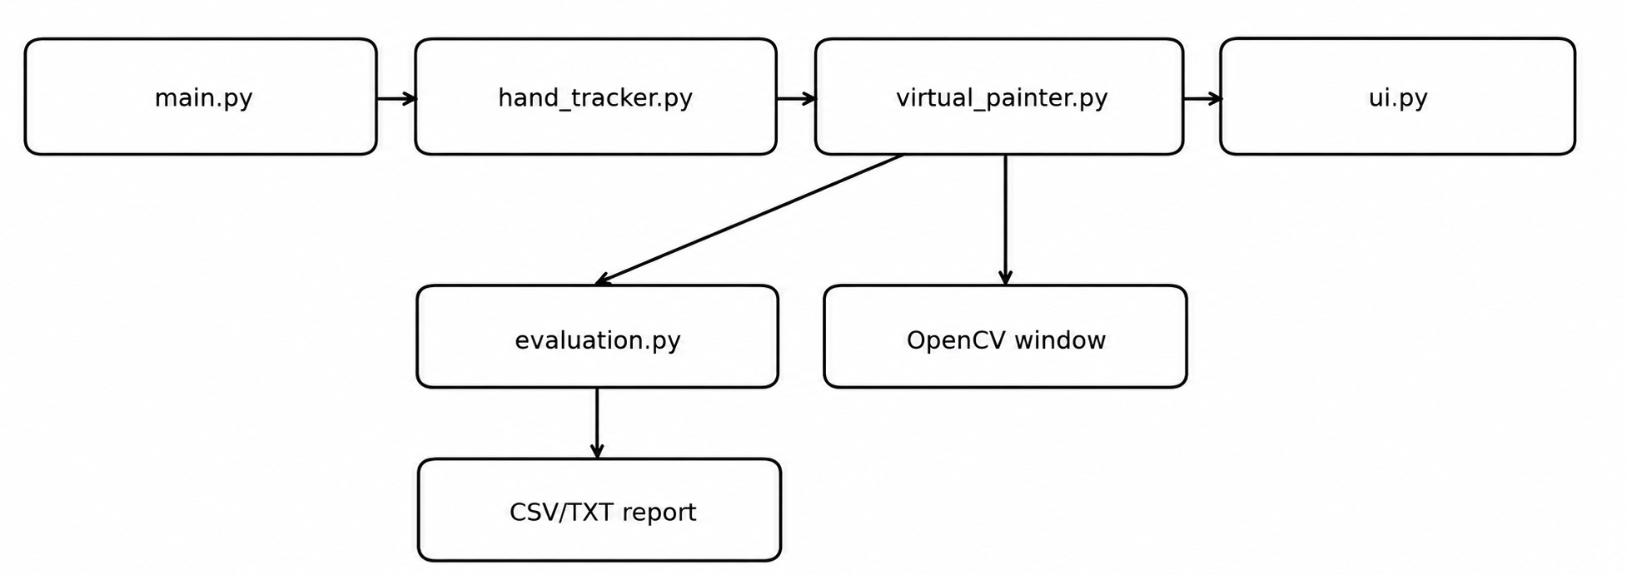
Fig 5.1 Software Module Interaction

5.4 Data Flow
The primary data object is a video frame represented as a NumPy array. MediaPipe receives an RGB representation and returns hand landmarks. The relevant landmark coordinates are converted into integer pixel coordinates. The smoothed fingertip position becomes the control point for UI selection or drawing. The persistent canvas is another NumPy array of shape 720×1280×3. A temporary canvas is used only while previewing geometric shapes.

5.5 User Interaction Model
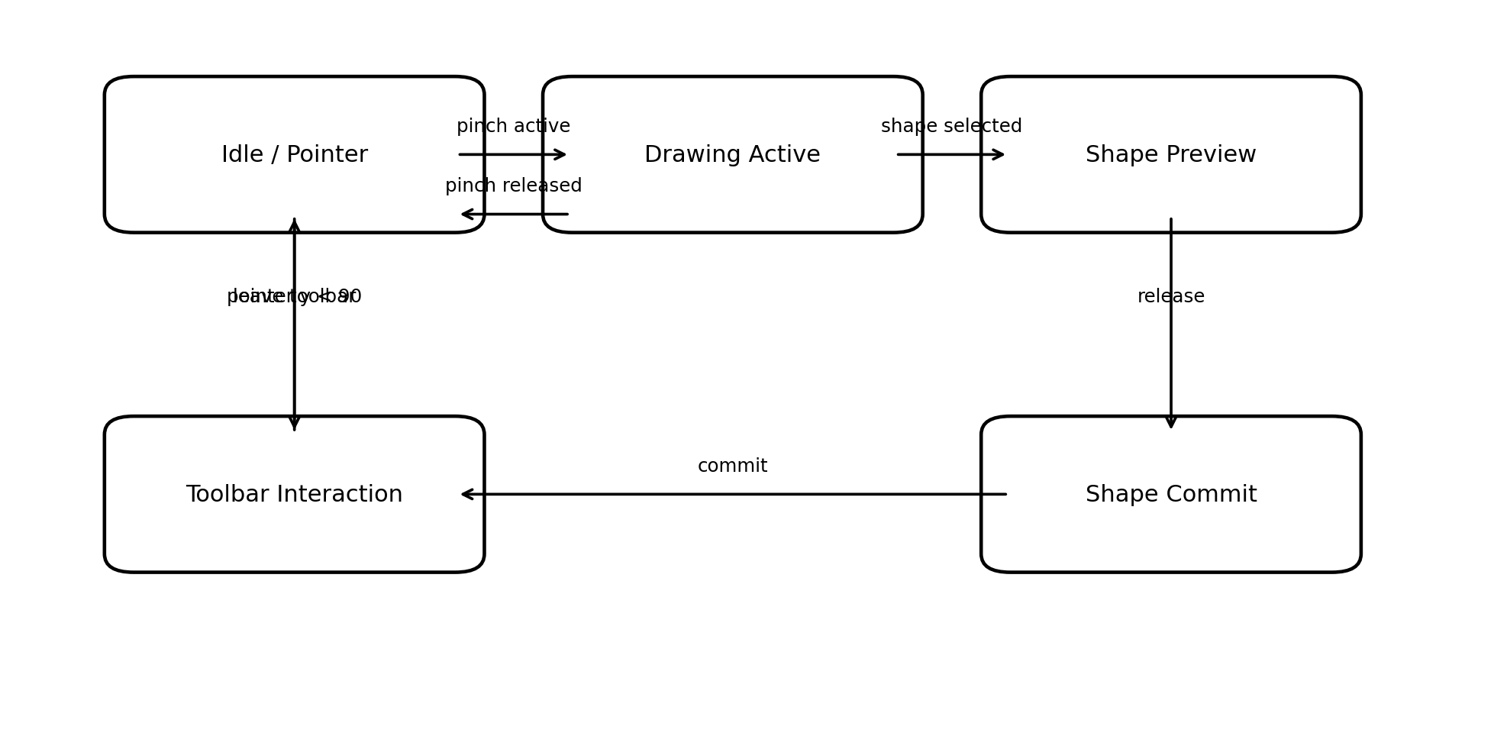
Figure 5.2: AirSketch Interaction State Model.
The interaction model can be understood as a small state machine. In the pointer state, the user can move the fingertip without creating a stroke. When the pinch becomes active in the drawing region, a drawing interaction starts. For brush and eraser, subsequent positions extend the stroke. For geometric tools, subsequent positions update a temporary preview. When the pinch is released, the selected shape is committed to the persistent canvas. The toolbar forms a separate interaction region and takes precedence over drawing when the pointer is above the configured boundary.
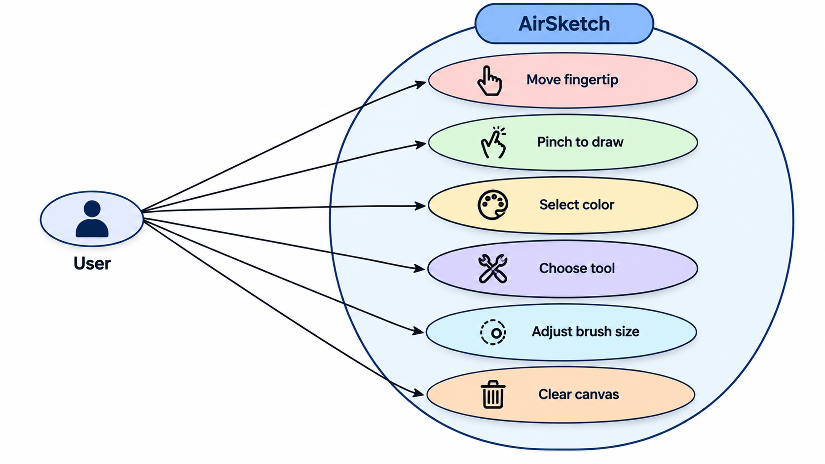

Figure 5.3: Primary AirSketch User Interactions.

5.6 User Interface Design
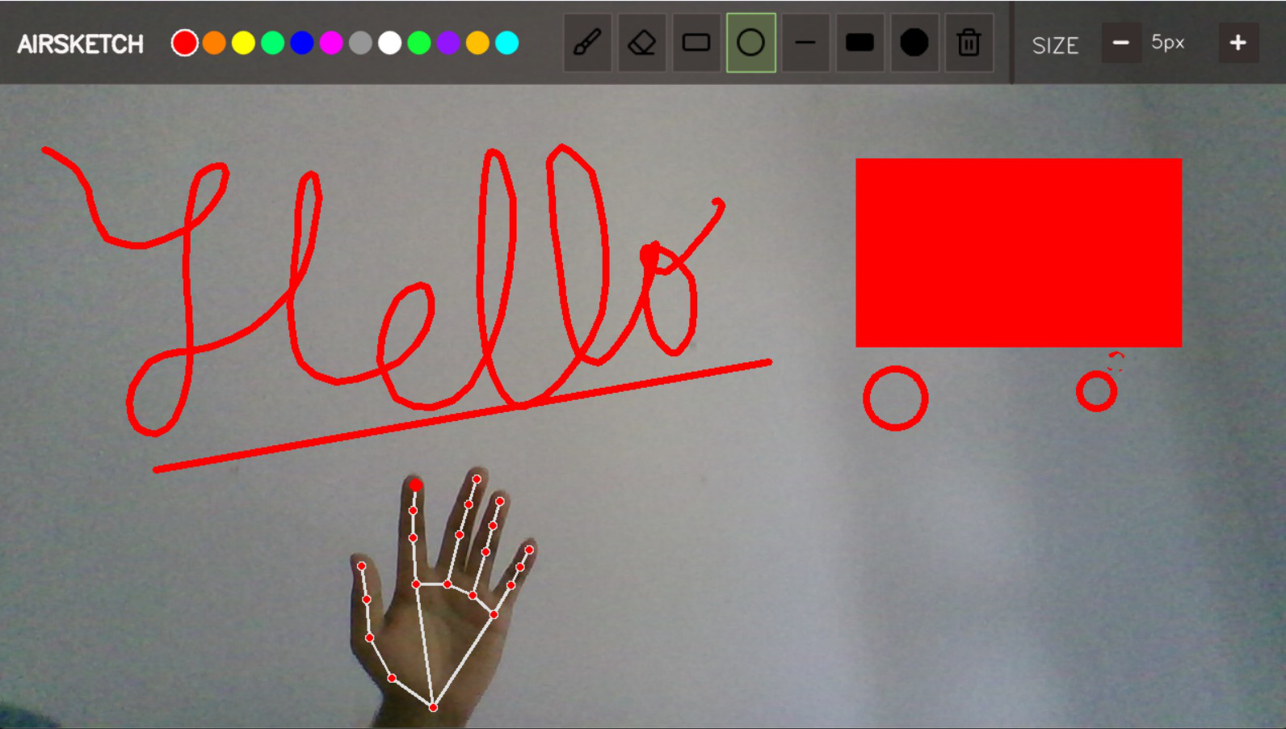
Figure 5.4: Representative AirSketch drawing and shape-creation interface from the research paper.
The current UI is drawn directly onto the OpenCV frame, allowing the controls and drawing area to be displayed within the same application window. The toolbar height is 82 pixels and occupies the upper portion of the interface. It displays the AIRSKETCH title, twelve colour circles, eight tool buttons, and brush-size controls. Tool icons are loaded from PNG assets to provide clear visual representations of the available operations. The selected tool is visually distinguished from the other buttons, providing immediate feedback about the current drawing mode.
The UI interaction handler applies a 0.3-second debounce interval. This is intended to prevent repeated selection when the fingertip remains over a control across several frames. Importantly, the debounce is applied to toolbar selection rather than to the continuous drawing trajectory, ensuring that drawing remains responsive and smooth during hand movement. The combination of visual feedback, simple spatial selection, and debounce handling provides a consistent interaction mechanism for the virtual canvas.

VI. ALGORITHMS AND METHODOLOGY

6.1 Video Acquisition
The main program initializes OpenCV VideoCapture(0), requests a working resolution of 1280×720, and continuously reads frames. Each valid frame is horizontally flipped before processing. The horizontal flip creates a mirror-like interaction view so that moving the hand toward the left or right of the screen feels consistent with the displayed image.
cap = cv2.VideoCapture(0)
cap.set(3, 1280)
cap.set(4, 720)
ret, frame = cap.read()
frame = cv2.flip(frame, 1)
Code fragment: camera initialization and mirror-view preparation.

6.2 Hand Landmark Detection
The hand tracker initializes MediaPipe Hands with max_num_hands=1, minimum detection confidence 0.75, and minimum tracking confidence 0.70. MediaPipe provides 21 landmarks. The implementation is intentionally limited to one hand, which simplifies the interaction state and avoids ambiguity when mapping a pointer to a toolbar or drawing surface.
self.hands = self.mp_hands.Hands(
max_num_hands=1,
min_detection_confidence=0.75,
min_tracking_confidence=0.7
)
Code fragment: MediaPipe Hands configuration in the current repository.

6.3 Coordinate Mapping
MediaPipe provides normalized landmark coordinates. The current implementation converts the index and middle fingertip coordinates into the fixed 1280×720 working space. For a normalized point (xn, yn), the current mapping is xp = floor(1280xn) and yp = floor(720yn). This direct mapping simplifies the implementation but creates a dependency on the configured working resolution.

6.4 Pinch Detection
The pinch detector uses the Euclidean distance between landmark 8 and landmark 12. If the distance is less than 70 pixels, the system sets pinch=True; otherwise pinch=False. The rule is deterministic, interpretable, and does not require a trained classifier.
distance = math.hypot(x2 - x1, y2 - y1)
pinch = distance < 70
Code fragment: deterministic pinch rule.
The threshold is expressed in the 1280×720 coordinate system. Because the threshold is not normalized to hand size, the apparent size of the hand and its distance from the camera can affect the interaction. The research paper identifies normalized thresholding as a future improvement.

6.5 Shape Rendering
The shape renderer supports five geometric modes. A rectangle uses the initial and current points as opposite corners. A line uses the same pair as endpoints. A circle uses the initial point as the centre and calculates the radius from the Euclidean distance to the current point. Filled variants use OpenCV’s negative thickness parameter. The selected brush thickness is passed to outline primitives.
radius = int(math.hypot(x2 - x1, y2 - y1))
cv2.circle(canvas, (x1, y1), radius, color, thickness)
Code fragment: circle radius and rendering logic.

6.6 Canvas Compositing
The drawing is not displayed as a separate opaque image. The implementation converts the selected drawing surface to grayscale and thresholds it at 5 to create a foreground mask. The inverse mask preserves the camera image in non-drawing regions. The foreground drawing and masked camera image are then added to form the final display. This produces the visual effect of drawing directly over the live camera feed.

6.7 Toolbar Interaction and Debouncing
When the smoothed fingertip lies above the toolbar boundary, the UI module takes control. Colour selection tests the distance from the pointer to each colour circle. Tool selection checks whether the pointer lies within each tool button. Brush-size controls increase or decrease the current index within the ten-element thickness list. The clear tool replaces the persistent canvas with a new zero-valued array and resets drawing state.
The UI uses a 0.3-second debounce. This prevents a fingertip remaining over a button from causing repeated selections at the video sampling rate. The separation between toolbar interaction and drawing interaction is therefore achieved by both spatial state and temporal debouncing.

6.8 Gesture and Tool Mapping
Input / Condition | Interpretation | System Action
Hand detected | Index fingertip available | Virtual pointer position
Distance < 70 px | Pinch active | Activate drawing state
Pinch + brush + motion | Continuous brush input | Draw line segments
Pinch + eraser + motion | Continuous eraser input | Draw black erasing path
Pinch + geometric tool | Shape interaction | Update temporary preview
Pinch release + geometric tool | Interaction completed | Commit shape
Pointer in toolbar | UI interaction mode | Interpret position as control selection
Pointer on colour | Colour control hit | Change current colour
Pointer on tool | Tool control hit | Change active tool
Pointer on size control | Size control hit | Increase/decrease thickness
Pointer on clear | Clear control hit | Reset persistent canvas

6.9 Methodology
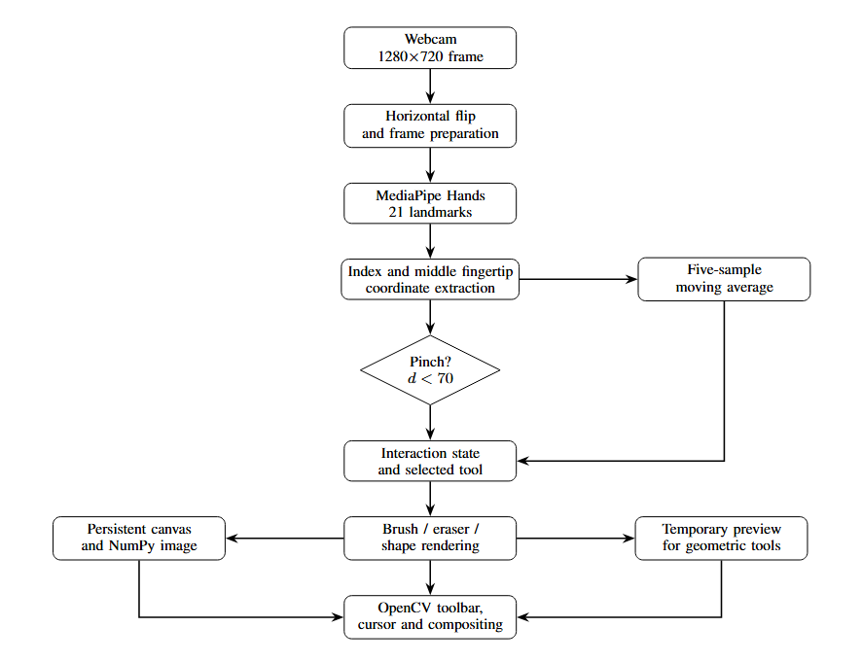
Figure 6.1: Architecture and Processing Pipeline

VII. SYSTEM IMPLEMENTATION

7.1 Development Environment
The current repository implementation is a Python desktop application. The research paper specifies MediaPipe 0.10.21, OpenCV 4.10.0.84, and NumPy 1.26.4. OpenCV handles camera acquisition, image conversion, drawing primitives, alpha compositing, and display. MediaPipe provides the hand landmark representation. NumPy provides the array representation used for the persistent and temporary canvases

7.2 Main Application Module
The main module creates the camera object, configures the requested resolution, creates a VirtualPainter instance, and enters the frame-processing loop. It also provides keyboard controls for the evaluation experiment. Pressing E toggles evaluation mode, 1 labels the current ground truth as pinch, 0 labels it as no pinch, R resets counters, S saves the evaluation report, and Q exits the application.
def main():
cap = cv2.VideoCapture(0)
cap.set(3, 1280)
cap.set(4, 720)
painter = VirtualPainter()
while True:
ret, frame = cap.read()
frame = cv2.flip(frame, 1)
final_frame = painter.process_frame(frame)
cv2.imshow(painter.window_name, final_frame)
Code fragment: simplified application loop based on the repository.

7.3 Hand Tracker Module
HandTracker encapsulates MediaPipe initialization and landmark processing. It converts BGR frames to RGB, invokes MediaPipe, draws the detected hand connections for visual feedback, extracts landmarks 8 and 12, computes their distance, determines pinch state, and smooths the index fingertip. When no hand is detected, the module returns None.

7.4 Virtual Painter Module
VirtualPainter is the central application object. It initializes a 720×1280×3 persistent canvas and temporary canvas, defines twelve colours, defines the ten brush-size levels, lists the eight tools, and creates the hand tracker, UI, and evaluator. Its process_frame method orchestrates all stages from hand data acquisition through drawing and final display.
The brush method joins the previous point and current point with cv2.line. The eraser uses the same trajectory but renders in black. Geometric tools are drawn on temp_canvas during interaction. On release, the final primitive is drawn onto the persistent canvas. The class then performs mask-based compositing and asks the UI object to render the toolbar.

7.5 User Interface Module
The UI module uses OpenCV drawing operations to create the toolbar. It loads eight PNG tool icons and supports alpha compositing. The toolbar contains twelve colour choices, eight tools, and brush-size controls. Selected tools are visually highlighted. The UI module uses pointer coordinates to identify which control has been selected and applies a 0.3-second debounce interval. The toolbar is rendered on every processed frame so that the available controls remain visible during interaction.

7.6 Evaluation Module
GestureEvaluator provides a frame-level evaluation mechanism. The evaluator maintains TP, TN, FP, and FN counters. During evaluation mode, a user supplies ground truth by pressing 1 for pinch or 0 for no pinch. The evaluator samples every third frame by default. For each accepted sample, it records a timestamp, actual label, predicted label, and fingertip distance in evaluation_results.csv.
During evaluation mode, the user supplies the ground truth by pressing 1 when the observed gesture represents a pinch and 0 when it represents a no-pinch state. To reduce redundant samples while maintaining sufficient evaluation data, the evaluator samples every third frame by default. For each accepted sample, the system records the timestamp, actual label, predicted label, and fingertip distance in evaluation_results.csv. This recorded data can subsequently be used to verify the calculated performance metrics and analyse individual prediction errors.
accuracy = (tp + tn) / total
precision = tp / (tp + fp) if (tp + fp) else 0.0
recall = tp / (tp + fn) if (tp + fn) else 0.0
f1 = 2 * precision * recall / (precision + recall)
Code fragment: core evaluation metric calculations.

7.7 Configuration and Dependencies
The repository requirements file pins three packages: mediapipe==0.10.21, opencv-python==4.10.0.84, and numpy==1.26.4. Pinning these versions improves reproducibility of the current environment. The standard-library modules csv, os, datetime, math, time, and collections are used by the source files and do not require separate installation.

VIII. TESTING AND EVALUATION

8.1 Testing Strategy
Testing was organized around two complementary goals. Functional testing checks whether the user-facing drawing and interface features respond to the intended hand interactions. Quantitative evaluation checks the pinch detector using labelled samples. The latter is implemented directly in the repository through GestureEvaluator and produces a confusion matrix and standard binary classification metrics.

8.2 Pinch Detection Evaluation
The research paper reports an evaluation of 293 samples. The confusion matrix contains 137 true negatives, 148 true positives, zero false positives, and eight false negatives. The evaluator samples every third frame when a ground-truth label has been selected and a hand is detected. This procedure is important because the reported result is a frame-level evaluation under the project’s own labelling setup, not a participant-independent benchmark.
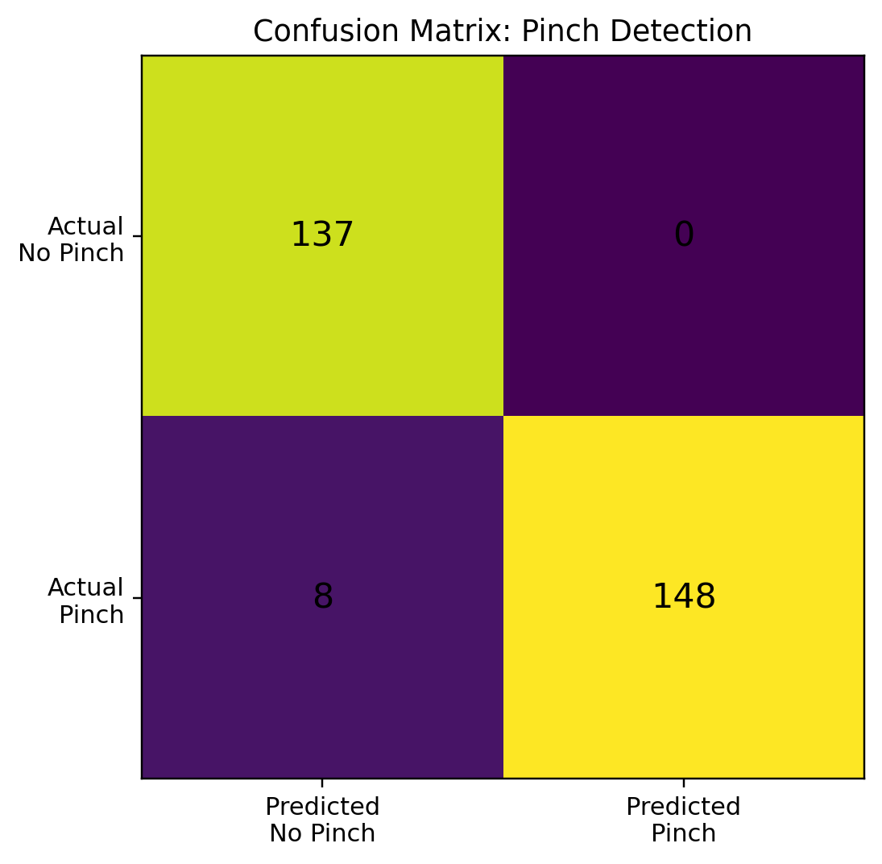
Figure 8.1: Confusion matrix for the reported 293-sample pinch evaluation.

8.3 Evaluation Methodology
Evaluation mode is toggled from the main application. The evaluator stores the current ground-truth label as either 0 or 1. A sample is considered only when a ground-truth label is present, a hand is detected, and the sampling interval is reached. The predicted value is the Boolean pinch state returned by HandTracker. Each accepted sample is written to a CSV file together with a timestamp and fingertip distance.
The use of explicit ground-truth labelling makes the experiment reproducible at the software level, but it also means that the quality of the result depends on the labelling procedure and test conditions. The current evaluation does not report the number of participants, lighting categories, camera models, or independent test sessions. Consequently, the numerical metrics should be interpreted as evidence about the available evaluation samples rather than a general population estimate.

8.4 Evaluation Metrics
Metric | Value | Interpretation for AirSketch
Samples | 293 | Number of labelled pinch/no-pinch samples used
Accuracy | 97.27% | 285 of 293 samples were classified correctly
Precision | 100.00% | No false-positive pinch was observed
Recall | 94.87% | 8 of 156 actual pinch samples were missed
F1-score | 97.37% | Harmonic mean of precision and recall
FPR | 0.00% | No no-pinch sample was predicted as pinch
FNR | 5.13% | 8 actual pinch samples were predicted as no pinch

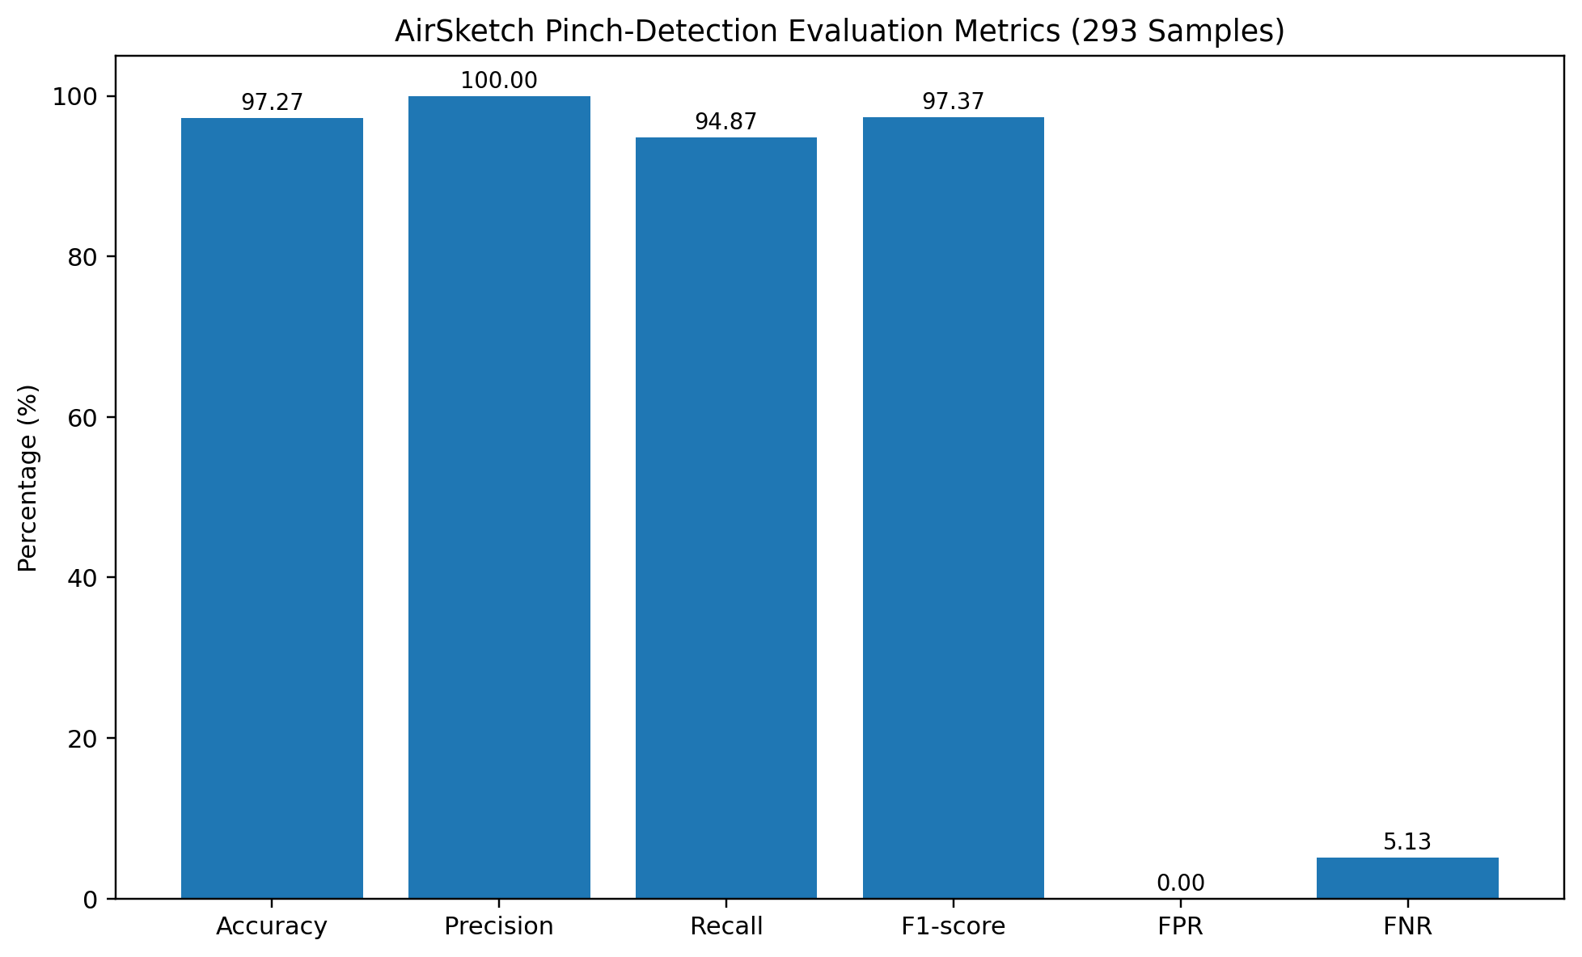
Figure 8.2: AirSketch pinch-detection evaluation metrics for 293 samples.

8.5 Performance Interpretation
The reported accuracy of 97.27% means that 285 of the 293 labelled samples were classified correctly. Precision is 100%, because all 148 predicted pinch samples were true pinch samples and there were no false positives. Recall is lower at 94.87% because eight actual pinch samples were missed. The false-negative rate of 5.13% therefore represents the complete set of observed classification errors in the available evaluation.
From the interaction perspective, false positives and false negatives have different effects. A false-positive pinch could cause an unintended drawing action, while a false negative can prevent an intended stroke from starting or continuing. The current evaluation observed no false positives, but eight false negatives. Future threshold adaptation or temporal stabilization could therefore focus on reducing missed pinch states while preserving the low false-positive rate.

IX. RESULTS AND DISCUSSION

9.1 Functional Results
The implementation demonstrates the complete interaction pipeline from camera input to drawing output. Representative screenshots show the hand landmarks overlaid on the detected hand, the fingertip used as the interaction point, and drawing content rendered directly over the camera view. The research paper explicitly describes the images as functional demonstrations rather than quantitative measurements of latency, accuracy, or robustness.
Figure 9.1: Representative drawing and shape-creation output from AirSketch.
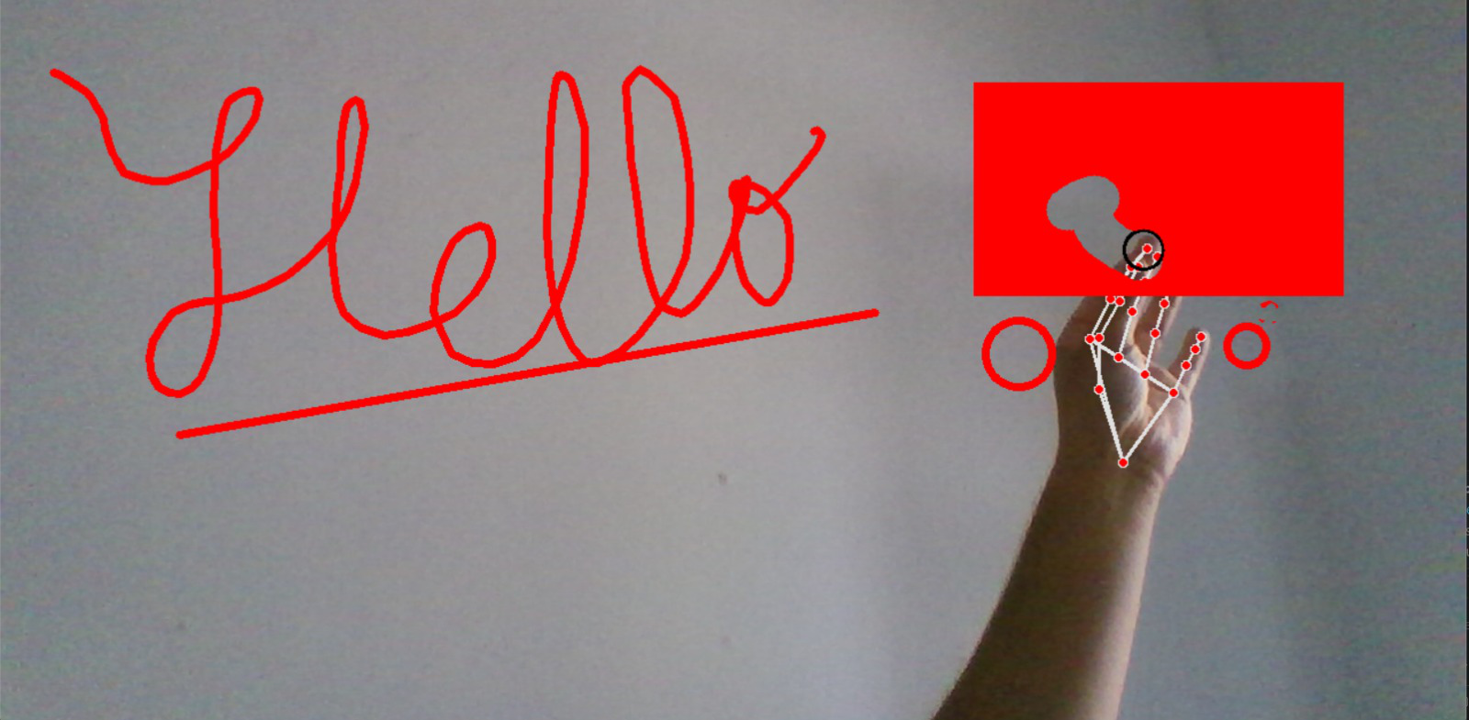
Figure 9.2: Representative hand-based interaction with previously drawn content.

9.2 Drawing and Shape Results
The output demonstrates freehand strokes, a straight line, and geometric shapes within the same interaction session. The brush renders a continuous polyline from successive fingertip positions. The shape tools provide a temporary preview while the user moves the fingertip with an active pinch and commit the selected primitive when the pinch is released. This prevents the persistent canvas from accumulating intermediate shape previews.
The eraser follows the same trajectory mechanism as the brush but uses black pixels and the current brush thickness. The clear tool replaces the persistent canvas with a zero-valued image. These operations demonstrate that the gesture layer is not limited to a single drawing command; it provides a compact control language for multiple canvas operations.

9.3 User Interface Results
The toolbar provides a compact set of controls without requiring keyboard-driven tool selection during normal interaction. Twelve colour choices are displayed as circles, eight tools are represented by icons, and brush thickness is controlled with decrement and increment buttons. The selected tool is visually highlighted, providing feedback about the current state.
The pointer can move into the toolbar region without creating a drawing stroke because the toolbar condition takes precedence. The 0.3-second debounce prevents a stationary fingertip from repeatedly triggering the same control. This separation is an important part of the interaction design because a virtual pointer needs a way to distinguish pointing from drawing.

9.4 Interaction Characteristics
The five-sample moving average reduces small fluctuations in fingertip coordinates. The filter is deliberately simple and predictable. It does not estimate velocity or acceleration and does not adapt its smoothing strength to movement speed. Consequently, it provides basic stabilization while leaving room for more advanced filters in future versions.
The current interaction model uses one hand and a binary pinch state. This makes the system easier to understand and reduces the need for training data. At the same time, the limited state vocabulary constrains the number of distinct commands that can be represented naturally. The research paper identifies richer gesture vocabularies and learned classifiers as possible future improvements.

9.5 Discussion
The results support the feasibility of a lightweight webcam-based drawing interface. The functional screenshots show that hand movement can be converted into both continuous and discrete drawing actions. The pinch evaluation shows that the deterministic activation rule performed consistently on the available labelled samples. The strongest numerical characteristic is the absence of false positives in the evaluation set; the main observed error mode is missed pinch detection.
The system should nevertheless be evaluated within its stated scope. The project does not establish that MediaPipe or the AirSketch interaction model is universally accurate under arbitrary lighting, backgrounds, camera distances, users, or hand poses. The research paper deliberately avoids such a claim. Instead, the results show that the chosen configuration can support a practical drawing interaction under the tested conditions.

9.6 Comparison with Related Approaches
The research paper includes a limited numerical comparison with AO-Finger. AO-Finger reports 83% pinch precision in its sample-level evaluation, while AirSketch reports 100% precision on its own evaluation samples. The paper explicitly warns that these numbers are not a direct benchmark because the systems use different sensing modalities, datasets, participants, gesture definitions, sampling procedures, and evaluation protocols. The comparison therefore illustrates a difference in reported evaluation results rather than establishing superiority.From a system-design perspective, AirSketch trades sensing richness for simplicity. It uses a standard RGB webcam instead of dedicated acoustic-optic or depth hardware. This makes the system easier to reproduce and modify, while also making it more dependent on visual conditions.

X. CONCLUSION AND FUTURE SCOPE

10.1 Conclusion
AirSketch demonstrates a complete real-time virtual drawing interaction using a conventional RGB webcam, MediaPipe hand landmarks, OpenCV, and NumPy. The project does not attempt to create a new hand-tracking model. Instead, it integrates established landmark detection with a deterministic pinch-based interaction model and a multi-tool drawing interface.
The system uses the index fingertip as the virtual pointer and the distance between the index and middle fingertips as the activation signal. A 70-pixel threshold determines the pinch state, while a five-sample moving average reduces fingertip jitter. The drawing engine supports brush, eraser, line, rectangle, circle, filled rectangle, filled circle, and clear operations. The UI provides twelve colours and ten brush-size levels.
The quantitative evaluation reported in the research paper contains 293 samples and produces 97.27% accuracy, 100.00% precision, 94.87% recall, and 97.37% F1-score. The confusion matrix contains 148 true positives, 137 true negatives, zero false positives, and eight false negatives. These results demonstrate consistent pinch detection on the available evaluation set, while the absence of environmental and multi-user benchmarking means that they should not be generalized beyond the tested conditions.

10.2 Current Limitations
• Only one detected hand is processed.
• The working coordinate space is fixed at 1280×720.
• The pinch threshold is fixed at 70 pixels and is not normalized by hand scale.
• The system depends on camera visibility and can be affected by lighting, background clutter, motion blur, and occlusion.
• The gesture vocabulary is small because no learned gesture classifier is used.
• The current evaluation focuses on pinch detection rather than comprehensive drawing quality or end-to-end user experience.
• Latency and frame-rate measurements are not included in the supplied evaluation results.

10.3 Future Enhancements

10.3.1 Multi-Hand Interaction
MediaPipe supports multi-hand tracking, so the application could be extended to track two hands. A future interaction design could assign one hand to navigation or canvas manipulation and the other to drawing. Such an extension would require explicit role assignment and state management to avoid ambiguous commands.

10.3.2 Scale-Normalized Pinch Threshold
A fixed pixel threshold makes the pinch condition dependent on hand size in the image. A normalized distance could divide fingertip distance by a reference hand dimension, such as a wrist-to-metacarpal distance. This would make the activation condition less sensitive to camera distance and apparent hand scale.

10.3.3 Adaptive Smoothing
The current five-sample moving average treats slow and fast movements similarly. Future versions could use velocity-aware smoothing, exponential smoothing, Kalman filtering, or other temporal techniques. The objective would be to reduce jitter while limiting lag during rapid drawing.

10.3.4 Richer Gesture Vocabulary
Additional static or dynamic gestures could be mapped to undo, redo, save, shape switching, zoom, canvas translation, or other commands. A lightweight classifier could be introduced for gestures that are difficult to represent through simple geometry. The research paper recommends such an extension while noting the associated dataset and validation requirements.

10.3.5 Improved Evaluation
A more extensive evaluation could include multiple users, multiple cameras, different lighting conditions, different backgrounds, different camera distances, and repeated sessions. It could report latency, frame rate, stroke deviation, task completion time, false activation frequency, and user satisfaction. Such an evaluation would provide stronger evidence about real-world robustness.

10.3.6 Persistent Drawing and Sharing
Future versions could provide explicit save and export operations for drawings, allowing users to store images and reopen them later. Cloud storage could be added if the application is later redesigned as a networked or web-based system. Such functionality is outside the current repository implementation.

10.4 Applications
• Educational demonstrations of computer vision and human–computer interaction.
• Touchless creative sketching and rapid visual ideation.
• Interactive classroom or presentation tools.
• Experimental accessibility-oriented interfaces.
• Gesture-based entertainment and interactive installations.
• Prototype environments for studying hand gesture interaction.
• Future integration with handwriting recognition or AI-assisted drawing systems.

REFERENCES
[1] C. Xu, B. Zhou, G. Krishnan, and S. Nayar, “AO-Finger: Hands-free Fine-grained Finger Gesture Recognition via Acoustic-Optic Sensor Fusing,” Proceedings of the CHI Conference on Human Factors in Computing Systems, 2023, doi: 10.1145/3544548.3581264.
[2] H. Chang, P. Ren, B. Zhang, D. Li, T. Han, H. Zhang, L. Xie, H. Chen, and E. Yin, “OMG-Bench: A New Challenging Benchmark for Skeleton-based Online Micro Hand Gesture Recognition,” 2026.
[3] H. Jand and S. Ranjan, “Air Writing App with Real-Time Hand Tracking and Handwriting Recognition using Fingertip Detection and Drawing,” International Journal on Recent and Innovation Trends in Computing and Communication, vol. 11, no. 10, pp. 1147–1153, 2023.
[4] S. A. Swathi, “Air Canvas Hand Tracking,” Journal of Emerging Technologies and Innovative Research, vol. 11, no. 11, 2024.
[5] H. Mahmud, M. M. Morshed, and Md. Kamrul Hasan, “A Deep Learning-based Multimodal Depth-Aware Dynamic Hand Gesture Recognition System,” 2021.
[6] A. Sharma, A. Mittal, S. Singh, and V. Awatramani, “Hand Gesture Recognition using Image Processing and Feature Extraction Techniques,” Procedia Computer Science, vol. 173, pp. 181–190, 2020, doi: 10.1016/j.procs.2020.06.022.
[7] J. Qi, L. Ma, Z. Cui, and Y. Yu, “Computer vision-based hand gesture recognition for human-robot interaction: a review,” Complex & Intelligent Systems, vol. 10, pp. 1581–1606, 2024, doi: 10.1007/s40747-023-01173-6.
[8] A. Morajkar, A. M. James, M. Bagwe, A. S. James, and A. Pavate, “Hand gesture and voice-controlled mouse for physically challenged using computer vision,” Advanced Engineering Days, vol. 6, pp. 127–131, 2023.
[9] N. Anithadevi, S. Palanisamy, S. S. Rubini, and S. Shrestha, “MediaPipe-LSTM-Enhanced Framework for Real-Time Dynamic Sign Language Recognition in Inclusive Communication Systems,” Engineering Reports, 2025.
[10] L. Quan, Q. Guo, X. Xie, S. Chen, X. Li, and Y. Liu, “Towards Understanding the Faults of JavaScript-Based Deep Learning Systems,” Proceedings of the IEEE/ACM International Conference on Automated Software Engineering, 2022, doi: 10.1145/3551349.3560427.
[11] R. Vasavi, N. Rahul, A. Snigdha, K. J. Moses, and S. V. Simha, “Painting with Hand Gestures using MediaPipe,” International Journal of Innovative Science and Research Technology, vol. 7, no. 12, 2022.
[12] J. Moreira, “Dynamic LIBRAS Gesture Recognition via CNN over Spatiotemporal Matrix Representation,” arXiv:2603.25863, 2026.
[13] H. X. G. Lim, X. Cui, Y. S. Rawat, and S.-N. Lim, “AirSketch: Generative Motion to Sketch,” Advances in Neural Information Processing Systems (NeurIPS), 2024, arXiv:2407.08906.
[14] S. Barade, P. Kadam, P. Vedpathak, and N. S. Bahirame, “Virtual Write and Clear Application: A Gesture-based Drawing Tool using Mediapipe and OpenCV,” International Journal for Multidisciplinary Research in Science, Engineering and Technology, vol. 8, no. 3, 2025, doi: 10.15680/IJMRSET.2025.0803129.
[15] S. V. Tiwari, D. A. Vartak, V. R. Verma, A. I. Sayyed, and S. Khatu, “Virtual Hand Gesture Painting,” 2024.
[16] Code-Hish, “MajorProject: New Airsketch Codes,” GitHub repository, 2026. Available: https://github.com/Code-Hish/MajorProject/tree/main/New%20Airsketch%20Codes

